**Project Proposal**

**On**

**E-commerce**



**Admond Tamang**

**00172885**

**Computing Project**

**Level 5 Diploma in Computing**

**Softwarica College of IT and E-Commerce**

**Kathmandu, Nepal**

**2018/12/28**

**Submitted to: Kiran Rana**

**Abstract**

E-commerce is the purchasing, selling & exchanging goods and services over computer network or internet. It is transaction of buying and selling online.

This project deals with developing an e-commerce website for local brands to promote their work and increase their productivity. It provides the customers to purchase different products from various local manufacturers.

The project was implemented using a 3-tier approach.Laravel was used as front end and MySQL was used as database. Wamp was used as

**Acknowledgement**

This work is completed not by one's effort, but it cost the efforts of many valuable people. It is my great honor to convey special thanks to all those helping hands, making my project successful.

I would like to express my sincere gratitude to Softwarica College of IT and e-commerce, for giving the opportunity to submit this e-commerce project.

I would like to thank Mr. Kiran Rana, our project advisor, for guiding us your support and advise in every steps of the process.

Lately, I would like to thank my colleagues' friends for helping me throughout research process whenever in need.

Contents

Introduction 5

Problem background to the system 5

Justification 5

Aim 5

Objective 6

Overview of the project design 6

Analysis 9

Introduction to analysis 9

Object oriented analysis 9

Merits of your project 9

Pitfalls 9

Requirements 10

Functional requirement 10

Non-Functional requirement 10

MoSCoW prioritization 10

NLA 11

Initial class diagram 11

Use case 12

Architecture 15

Design 16

Justification(main) 16

Dynamic modelling 16

Sequence diagram 16

Activity diagram 17

Structural modelling 20

DFD or Context diagram 20

Database modelling 20

ER Diagram: 20

UI modelling (prototype) 23

Implementation 28

Testing 28

Black box testing 28

Unit Testing. 28

Other project issues 29

Conclusion 29

References and bibliography 29

References 29

Appendix 29

**Tables of figure**

Figure 1: Home Page 8

Figure 2: Login page 8

Figure 3: Add to cart 9

Figure 4: Check out 9

Figure 5: Initial Class diagram 13

Figure 6: Use case diagram of e-commerce 15

Figure 7: Three tier architecture 16

Figure 8: Sequence diagram of user placing an order 18

Figure 9: Activity diagram of ordering product 19

Figure 10: Edit user profile 20

Figure 11: Adding product 21

Figure 12: ER - diagram 22

**Keywords**

DFD - Data Flow Diagram

E-commerce - Electronic commerce

ERD - Entity Relationship Diagram

NLA - Natural Language Analysis

UX – User Experience

# Introduction

E-commerce is fast gaining ground as an accepted and used business paradigm. More and more business houses are implementing web sites providing functionality for performing commercial transactions over the web. It is reasonable to say that the process of shopping on the web is becoming commonplace.

## Problem background to the system

Previously user do not have known about the products arising in Nepalis market. The main problem of Nepal is there is not enough market and knowledge to sell the products. And people don’t know local Nepalis products. To problem can be solved by the e-commerce providing people the right products. This application will reduce the problems arise in previous types of e-commerce system.

## Justification

In today’s busy world, people don’t have time for their personal needs. And the technology is so fast that anyone can do anything by just sitting in a room. The internet is the way that helps a person in all aspects. If someone wish to buy and view things, he can buy online with the help of internet. Today there are very least organizations which are manual. Everything is going to be computerized and online whether it is banking, advertising or shopping. We are trying to help people to make their life easier by proving online shopping facility. In this we have introduced many modules like admin module and customer module. The customer has to register for any enquiry related to Nepalis products. The unregistered person can’t access this application. The registered customer can view details of clothes and he can buy of his choice and need. He must pay the price of products he/she wishes to buy. The admin module contains the access of admin on the application. The admin can change everything in the application. He can add, delete, update any information regarding the clothes. The project’s home page includes the registration link. The registered users can login to their account for their queries or buy products. And the unregistered users have first to register. The registration can be done by following the sign-up link.

## Aim

The aims that I want to achieve are listed below:

* Developer would post their website and provide services to the customer.
* Customer should easily interact with the website and buy websites according to their needs.

## Objective

The main objective is to satisfy the local manufacture and customer. Action that I will take to achieve my aim are:

* Customer will have the ability to sign-up their account and browse different products.
* Developers will have the facility to post their website and provide services to the customer.

## Overview of the project design

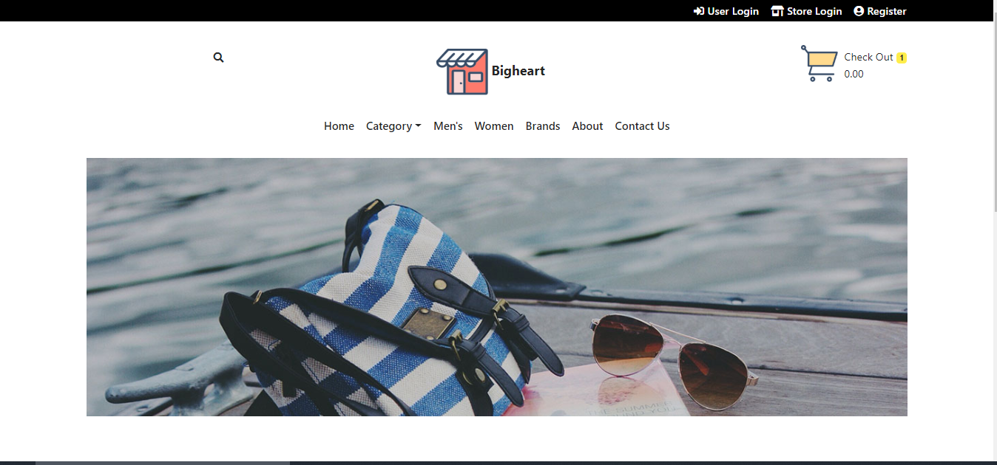

Figure 1: Home Page

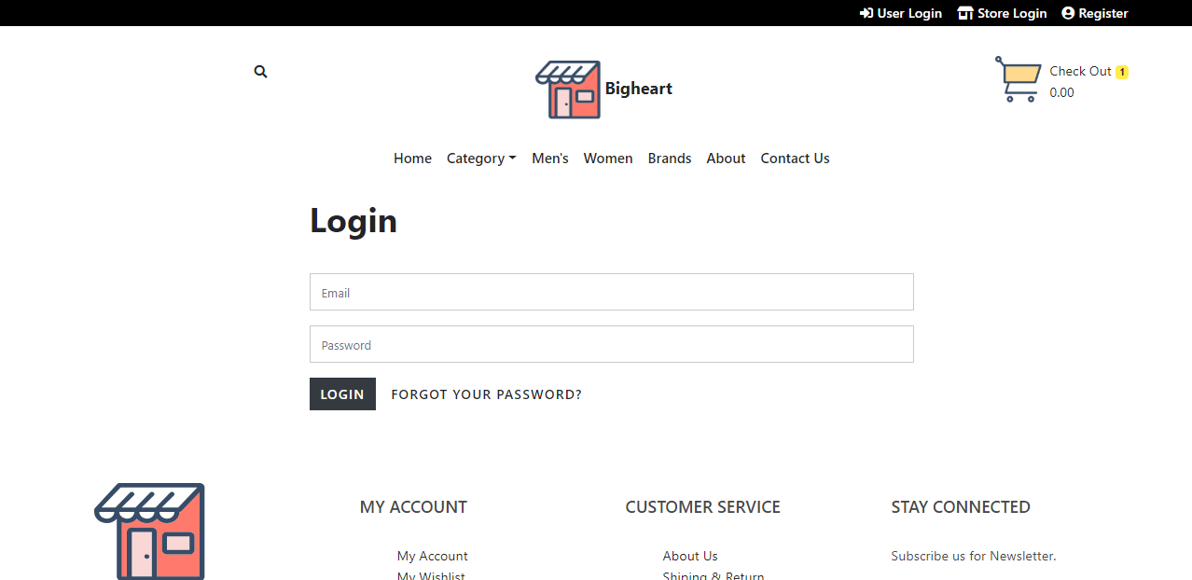

Figure 2: Login page

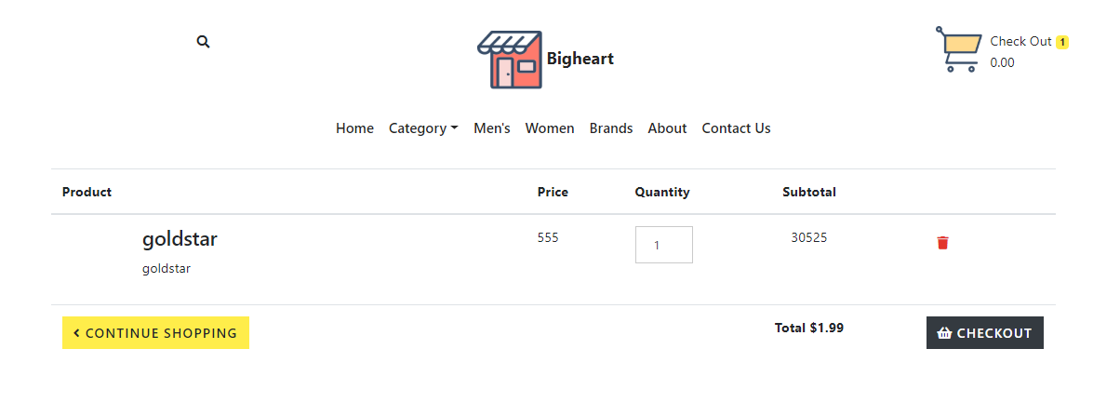

Figure 3: Add to cart

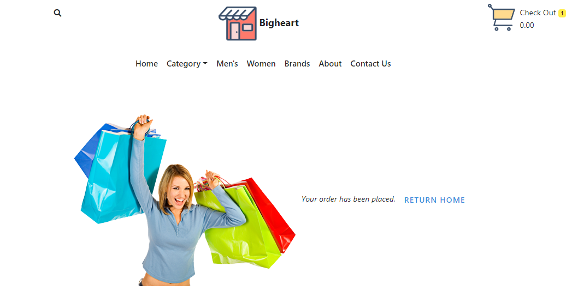

Figure 4: Check out

# Analysis

## Introduction to analysis

Analysis is a process to gather and understand facts, diagnosing the problems and the information about the project for better sympathetic before starting the to work on the project. It aids to resolve the diverse kinds of problematic actions that needs exhaustive communication among the system users and system developers. The lifecycle of project begins from analyses phase. During analyses phase requirements are collected like requirements analysis, information gathering, end-user requirements requests to be done.

The e-commerce system is hard to implement as it requires shops, customers to browse through shops, and system administrator to approve the requests for new shops and maintain category lists. This is a small-scale e-commerce project target to the local entrepreneur and manufacturer.

The main theme is that the customer can buy products from anywhere by using online payment system or can use cash on delivery. The database will maintain user and product details.

This system involves three types of users:

1. **Customer**

The customer is the person who buys products from the website.

1. **Store**

The store is the shop where customer can buy the products.

1. **Admin**

Admin administrate the behavior of both customer and store.

## Object oriented analysis

Object-oriented analysis is a process that groups items that interact with one another, typically by class, data or behavior, to create a model that accurately represents the intended purpose of the system. Object-oriented analysis does not factor implementation limitations into the model. (Anon., 2019)

## Merits of your project

* User experience (UX) is simple and interactive which focused on compatibility and usability with users.
* Sellers does not have to rent a physical store; hence it saves both time and money.

## Pitfalls

* No payment gateways.
* Cannot ship outside the county, it is limited to the country.

## Requirements

### Functional requirement

Those requirements which are related to behavioral aspect of the system. It specifies what the system should do. It includes business rule, administrative function and transaction correction.

### Non-Functional requirement

These requirements specify how the system should behave and the limits on requirements.

### MoSCoW prioritization

I have prioritized my features using MoSCoW prioritization technique.

**Note**

**M**=must have

**S**=should have

**C**=could have

**W**=won’t have

|  |  |  |  |
| --- | --- | --- | --- |
| **S/N** | **Requirement** | **MoSCoW** | **Functionality** |
|  | Login | M | F |
|  | Register | M | F |
|  | Post product | M | F |
|  | Add to Wishlist | C | F |
|  | Search product | M | F |
|  | Filter product | S | F |
|  | View user profile | M | F |
|  | Edit profile | M | F |
|  | Chat with owner | S | F |
|  | Buy product | M | F |
|  | Rate product | C | F |
|  | View product | M | F |
|  | Comment product | C | F |
|  | Generate bills | M | F |
|  | Verify store owner/ seller | M | F |
|  | Delete user | S | F |

**Non-functional requirement**

|  |  |  |
| --- | --- | --- |
| **S.N.** | **Requirement** | **Description** |
|  | Verification | To verify customer and store. |
|  | Security | Protect user and system from hacking. |
|  | User friendly | To provide smooth experience. |
|  | Efficient | Make system fast and reliable. |

## NLA

Natural Language Analysis helps us to find candidate class, attribute and their relationship.

A Bigheart is an IT company that focuses in buying and selling products online. The main objective is to promote local market.

The list the of candidate classes and candidate operations are:

|  |  |
| --- | --- |
| **Candidate classes** | **Candidate operations** |
| Admin | Update password, add staff, update staff, delete staff  View staff and view student |
| Store | Add product, Delivery, delete product, update product |
| User | edit profile, update profile |
| Order | Order product. |
| Product | Add product |
| Category | Add category |
| Shipping | Add shipping |
| Cart | Create, store, delete product |

## Initial class diagram

**Class Diagram**

Class diagram describes the attributes and operations of a system. It represents the static view of an application. Class diagram shows a collection of classes, interfaces, associations, collaborations, and constraints. It is also known as a structural diagram. (Anon., n.d.)

**Justifications:**

The Class Diagram is to model the static view of an application. It is forward and reverse engineering. Class diagrams are the only diagrams which can be directly mapped with object-oriented languages and thus widely used at the time of construction. It describes the responsibilities of a system.

**Class Notation**

A class notation consists of three parts:

1. Class Name
   * Determines the name of class and shown at top.
2. Class Attributes
   * Attributes are variables of any class (data members) in code
   * Data type of variable are shown after colon.
3. Class Operations
   * Operations are shown in the third partition. It defines behavior of a class.
   * After colon return type of method parameters are shown following the parameter name.

**Initial class diagram**

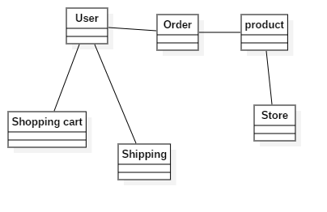

Figure 5: Initial Class diagram

x

I designed class diagram for my project because it helps to describes the responsibilities of the system which allows me to understand working mechanism of the system. As it holds class, attribute and operations which is required for the development of application. (htt)

## Use case

It shows the functionality of a system. It describes how a user's react with a system. A use case diagram is a representation of a user's interaction with the system that shows the relationship between the user and the different use cases in which the user is involved. To build the use case diagram, a set of specialized symbols and connectors are to be used. (Anon., n.d.)

**Justifications:**

The use case diagram describes a set of actions that some system can perform in collaboration with one or more external users of the system, gather the requirements of a system, identifies and clarifies the relationships between and among the actors and the use cases and identifies the external and internal factors influencing the system.

**Advantages:**

* It helps to collect the functional requirements of a system.
* It can serve as the basis for the estimating, scheduling and validating effort.
* It can also collect additional behavior that can improve system robustness.

**Disadvantages:**

* They do not capture the non-functional requirements easily.
* Difficult to manage scenario.
* It has poor identification of structure and flow.

**Use case notation**

Actors: Users that interacts with the system.

System: That consist different use cases.

Use case: action that is performed by actor.

I have used use case because it helps to represent action performed by actor via use-case.

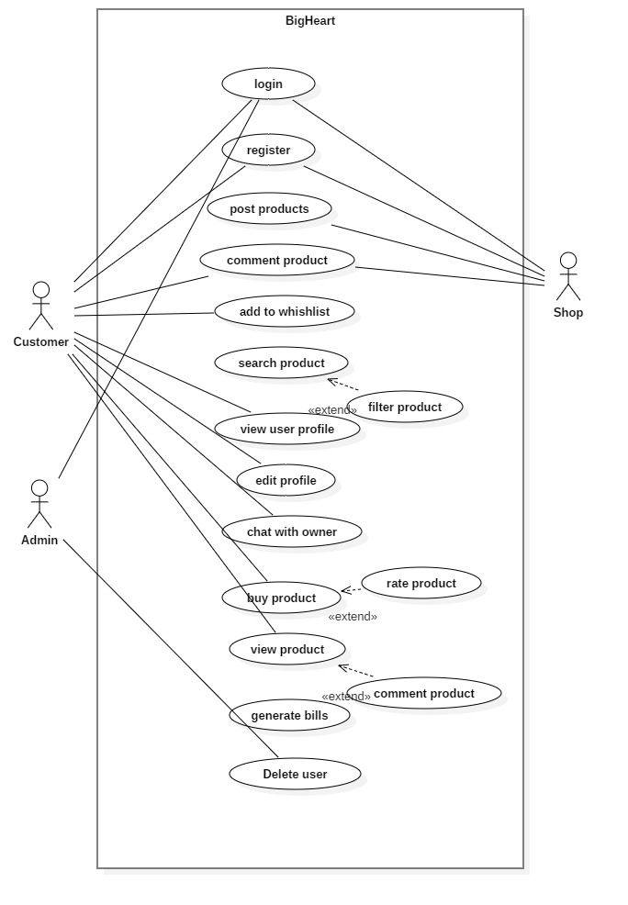

Figure 6: Use case diagram of e-commerce

## Architecture

3-tier architecture was used in the development of the project. It is divided into three layers. They are:

1. **Presentation**

Handles the interaction between user and the client business. For example, HTML5, CSS.

1. **Application**

Takes request from presentation tier and returns the output to presentation tier. For example, Java, .NET.

1. **Data tier**

Responsible for storing data and sending it to business tier. For example, MySQL, Oracle.

I have used 3 tier architectures because of following reasons:

1. **Scalability**

Middle tier can be added to make system run smoother. The system can work even hardware needs to be added and updated to load load-balance the presentation tier.

1. **Security**

Client is not directly access to the database. Middle layer protects the database tier ensuring strong security.

1. **Performance**

Presentation tier can cache requests, so network utilization is minimized and run smoothly.

1. **Maintainability**

It manages presentation code and business logic separately so change in business logic does not affect presentation layer.

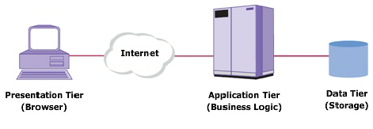

Figure 7: Three tier architecture

# Design

## Justification

The design phase seeks to develop detailed specifications that emphasize the solution to the user’s needs.it is the highest critical stage in developing of the system in relevant design appears in consequence of study and is changed into physical design. SDLC has six stages and individual of them is design stage which reach after analysis where the business needs is construct. The logical design produced during the analysis is turned into physical design.

## Dynamic modelling

### Sequence diagram

A sequence diagram is interaction between objects in a sequential order. Sequence diagrams describe how and in what order the objects in a system function.

sequence diagrams can be useful references for businesses and other organizations. Try drawing a sequence diagram to:

The reason of using sequence diagram are:

* Model the logic of a sophisticated procedure, function, or operation.
* See how objects and components interact with each other to complete a process.
* Plan and understand the detailed functionality of an existing or future scenario.

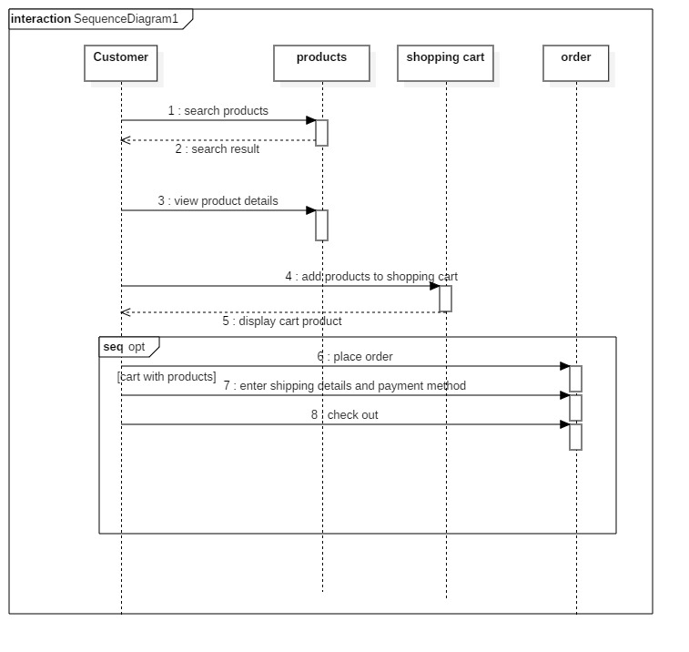

Figure 8: Sequence diagram of user placing an order

### Activity diagram

I had used activity diagram to illustrate the flow of system. An activity diagram focuses on condition of flow and the sequence in which it happens. It helps to understand the flow of programs on a high level. It also enables them to figure out constraints and conditions that cause events.

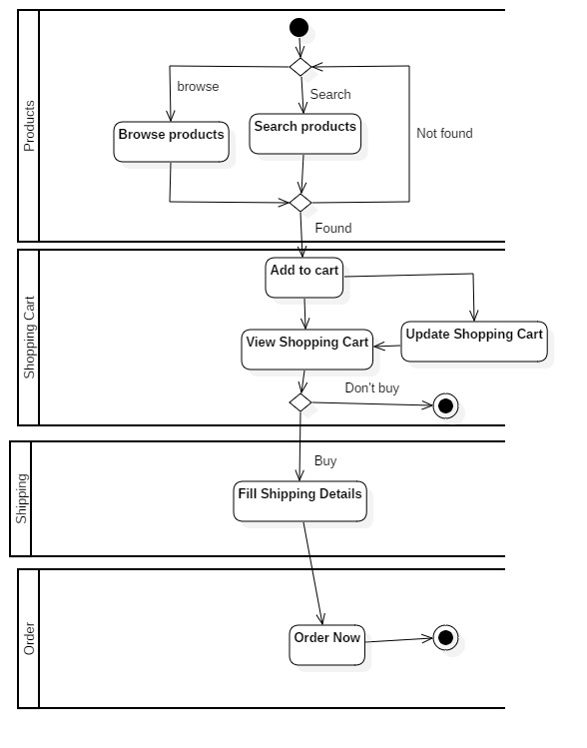

Figure 9: Activity diagram of ordering product

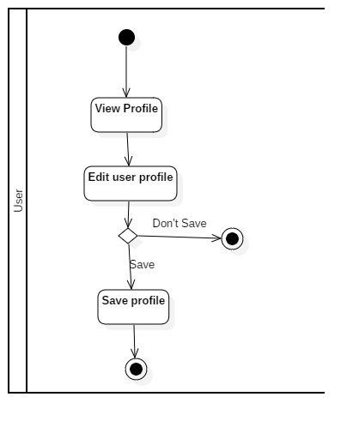

Figure 10: Edit user profile

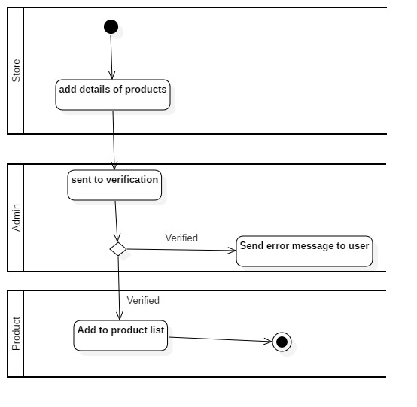

Figure 11: Adding product

I created activity diagram because it helps to show the flow operation in a system.

## Structural modelling

Architecture level class diagram (final class diagram)

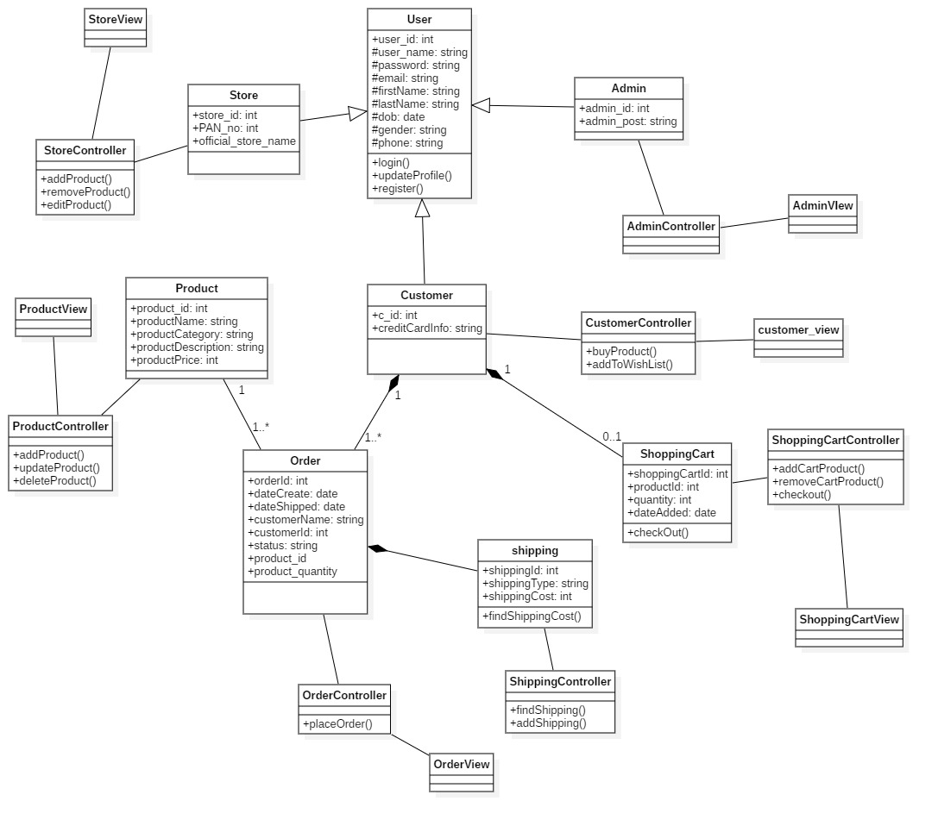

Figure 12: Final class diagram

## DFD or Context diagram

## Database modelling

### ER Diagram:

An entity-relationship diagram is a data modeling technique that graphically illustrates an information system's entities and the relationships between those entities. It is a conceptual and representational model of data used to represent the entity framework infrastructure.

**Justifications:**

The ER Diagram is to visualize database design ideas, so we have a chance to identify the mistakes and design flaws, and to make correction before executing the changes in database. By visualizing a database schema with an ERD, we have a full picture of the entire database schema through which we can easily locate entities, view their attributes and to identify the relationships they have with others.

**Advantages:**

* It is very simple if we know relationship between entities and attributes.
* It is better visual representation.
* It is an effective communication tool for database designer.

**Disadvantages:**

* It has limited constraints and specification.
* Information can be hidden in ER model.
* It is difficult to show data manipulation in ER model.

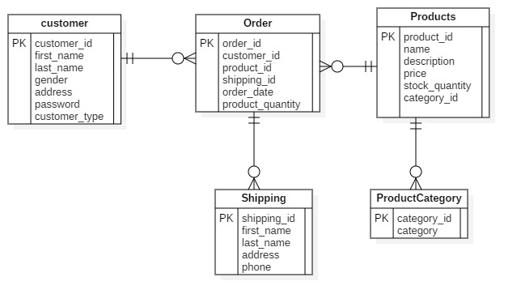

Figure 13: ER - diagram

### Data dictionary

## UI modelling (prototype)

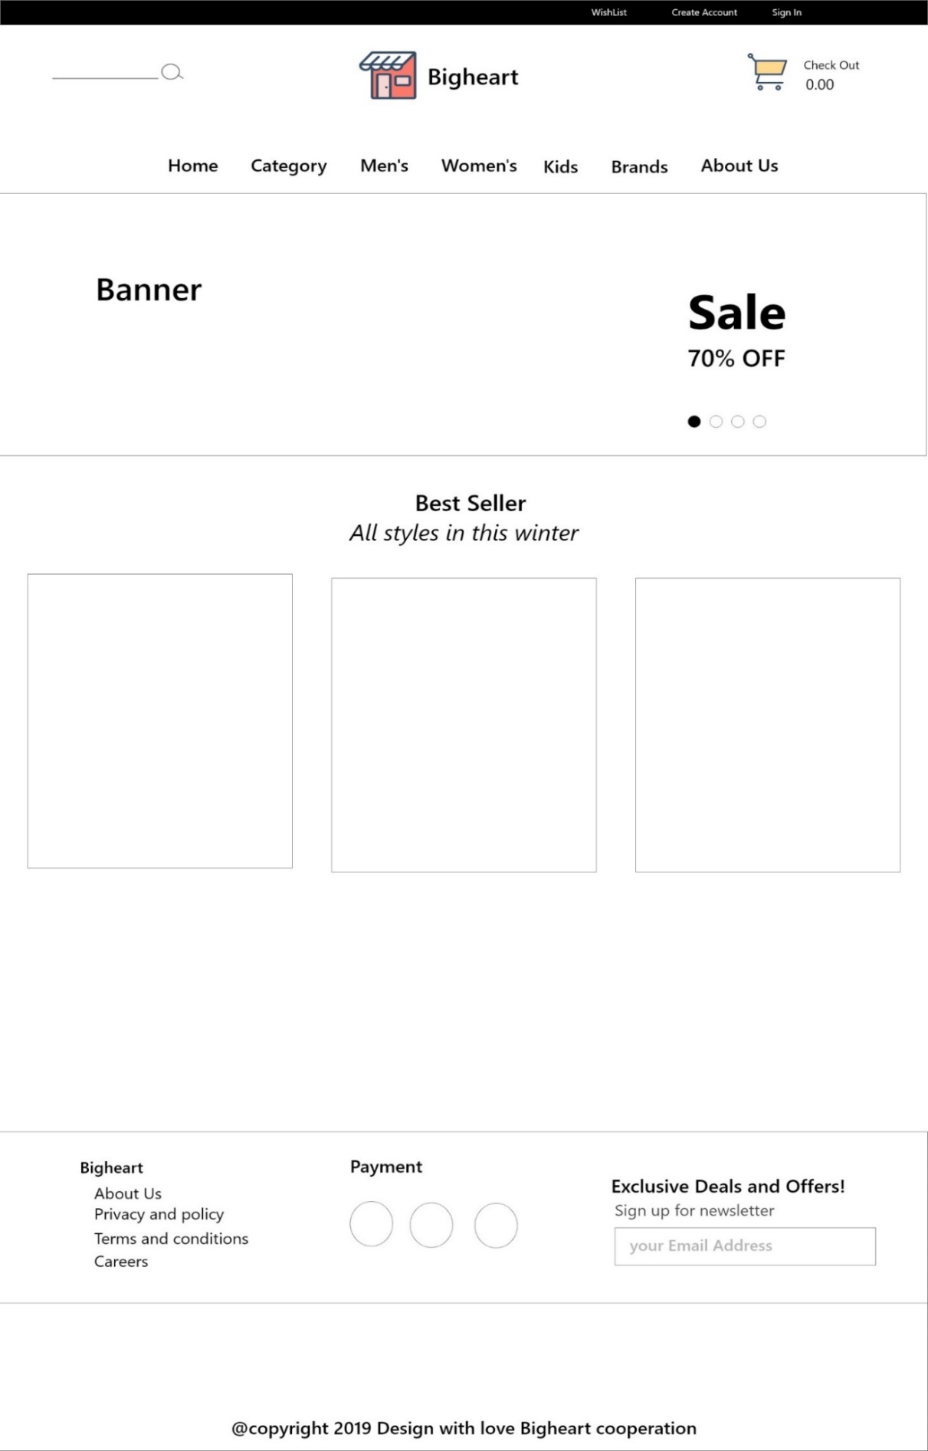

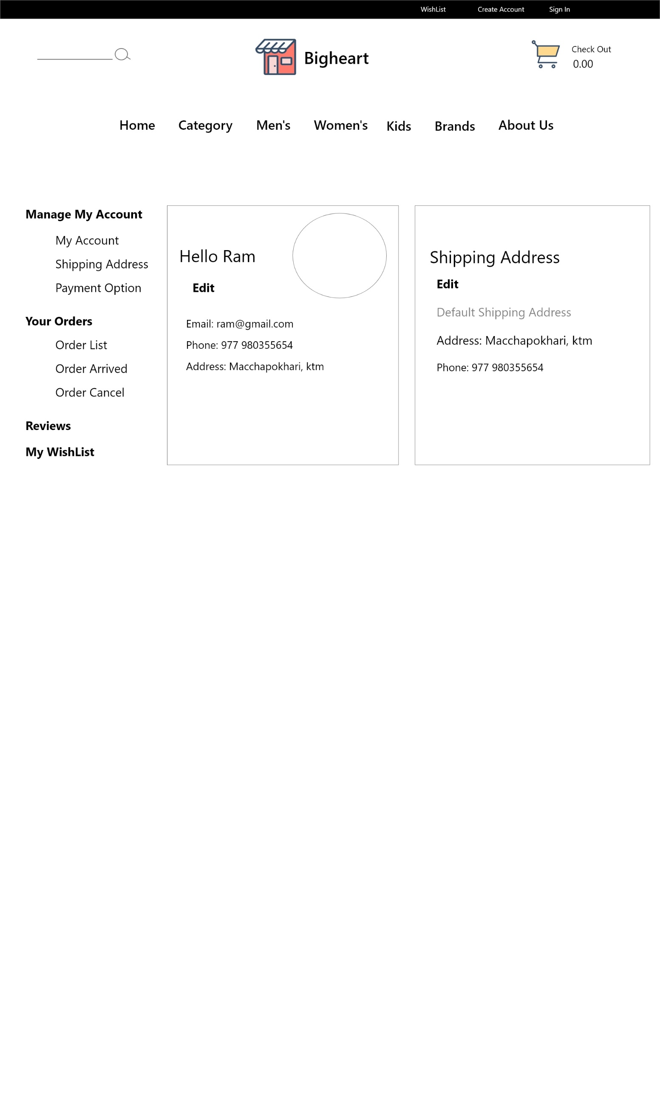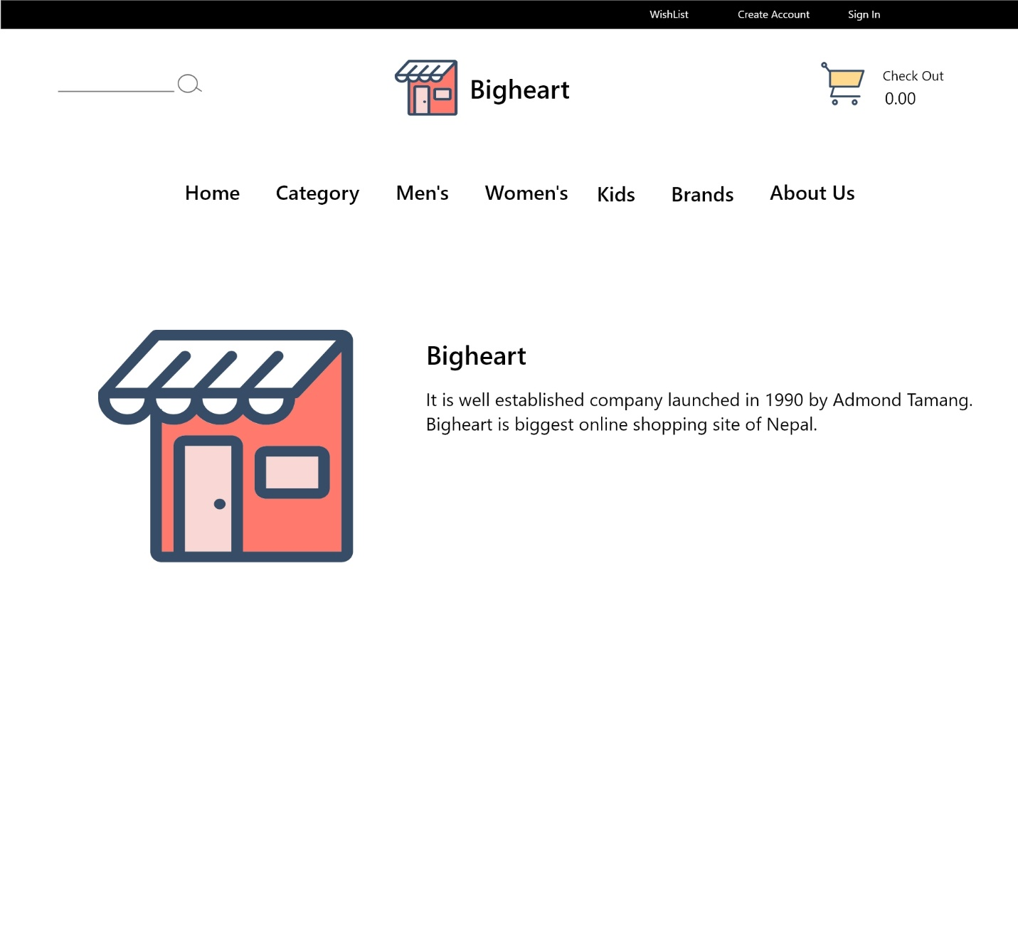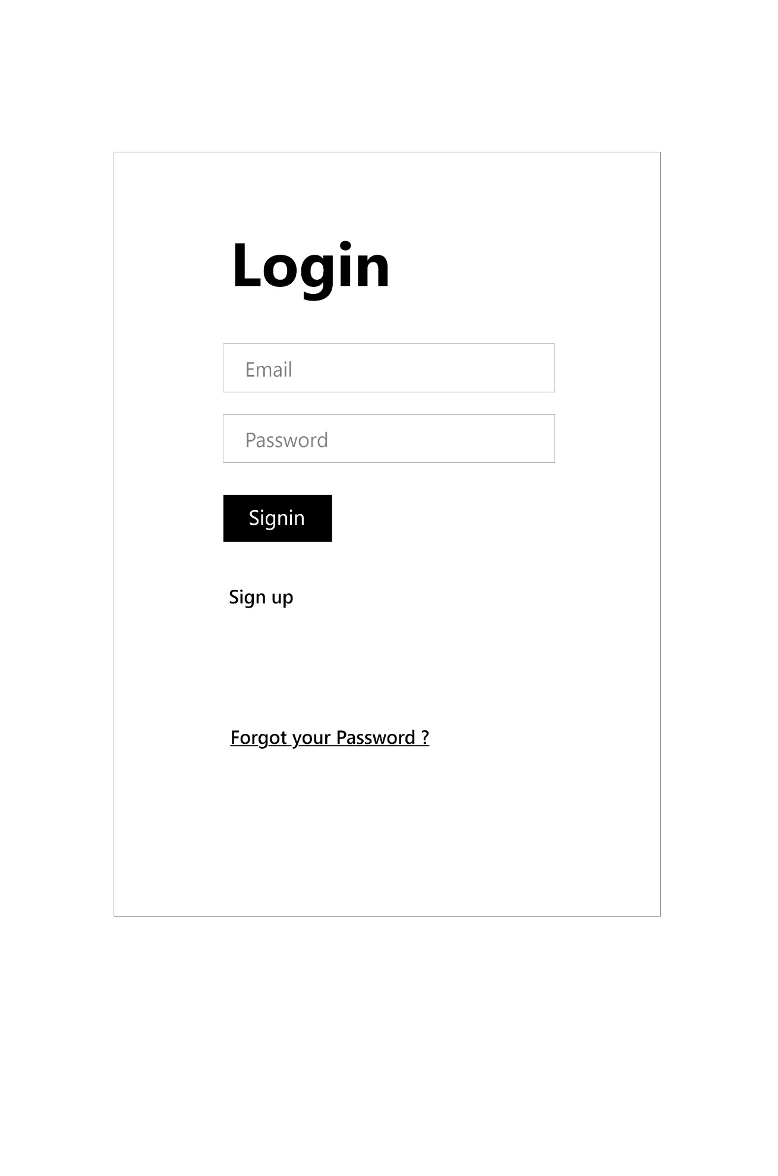

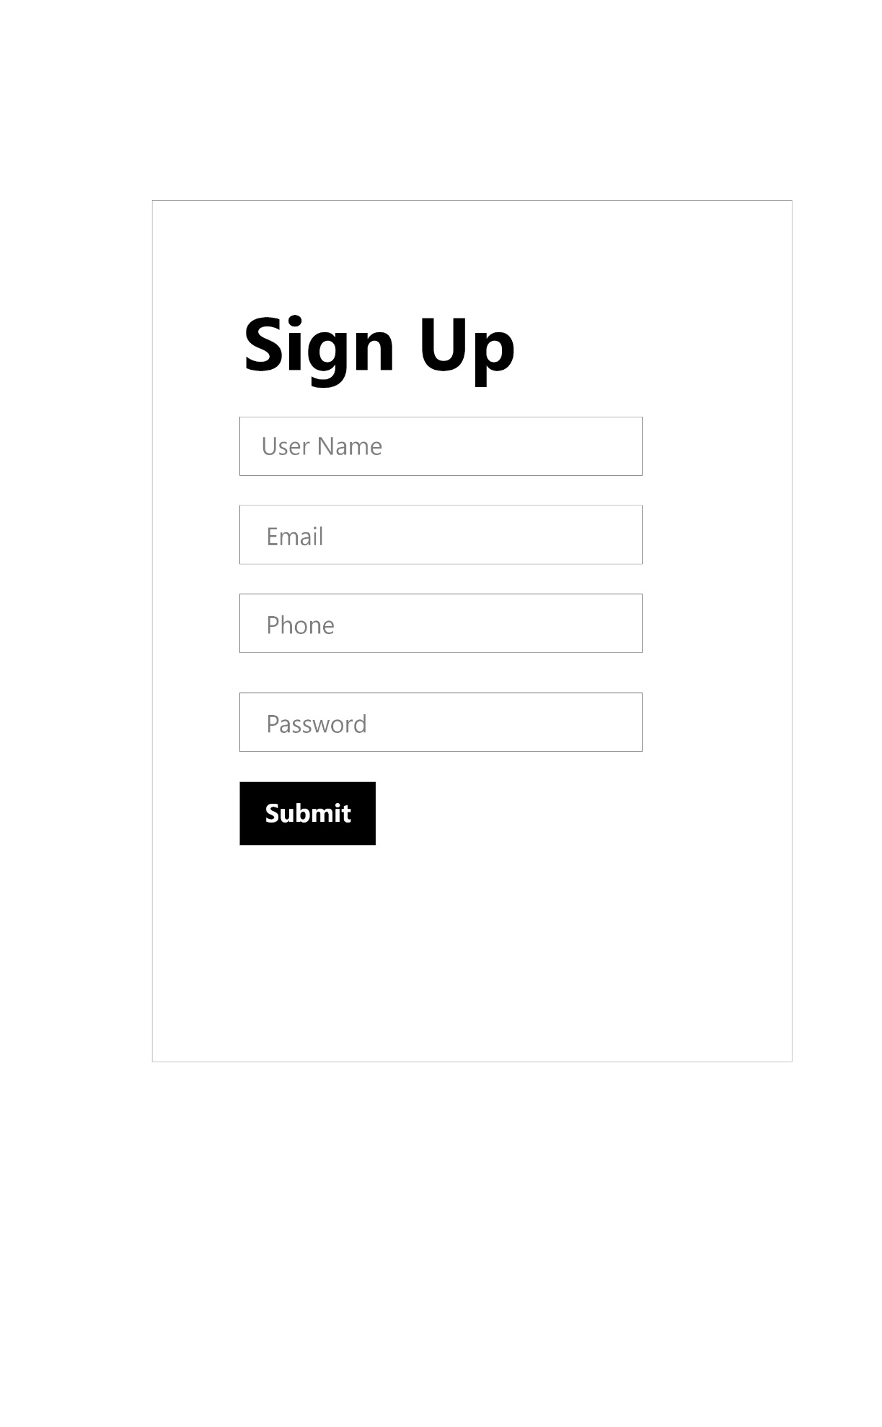

# Implementation

# Testing

It is the process of evaluating the function in the application in order to find the bugs in system. SDLC has six phases among them testing comes after implementing in SDLC.it is an integral part of software quality and it is important activity for supporting entire SDLC. testing must be done thorough strategic and showed throughout the SDLC for the finest outcomes which eventually aid in charge the cost of bug setting identical little. Testing not only shows a important part in SDLC for conference the values of an application but it also imitates in structure up the status of an organization.

The objective of testing is to ensure

* Software reliability
* Software quality
* System Assurance
* Optimum performance and capacity utilization

There are many types of testing to test software application like as: -

* Black box testing
* White box testing
* Unit testing
* Integration testing
* Usability testing
* System testing

### Black box testing

It is also known as UI testing. It tests the software without knowing the internal structure of program. All testing is done as customer’s point of view. Tester is only aware of what is software is supposed to do and unaware about how these requests are being processed. While tester is only known about the input and expected output of the software. The main purpose of black box testing is to check whether the software is working as expected as requirement. (admin, 2012)

**Test 1**

|  |  |
| --- | --- |
| **Test case no** | 1 |
| **Purpose of test** | To check route is working |
| **Test data** | / |
| **Expected result** | Visit home page |
| **Actual Result** | Successfully visited |
| **Test log (Status)** | Pass |



Figure 14: test case result

|  |  |
| --- | --- |
| **Test case no** | 2 |
| **Purpose of test** | To check whether user can register themselves or not |
| **Test data** | Clark buchanan, clark@gmail.net |
| **Expected result** | User should registered. |
| **Actual Result** | User is registered |
| **Test log (Status)** | Passed |

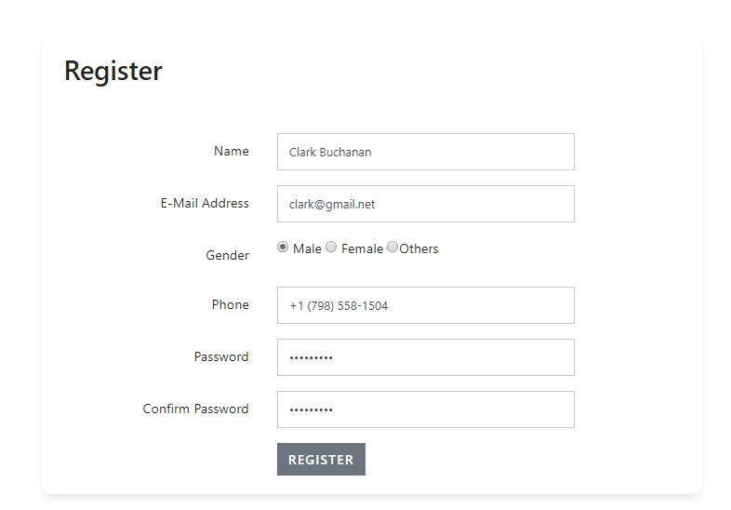

|  |  |
| --- | --- |
| **Test case no** | 3 |
| **Purpose of test** | To check whether user can search products or not |
| **Test data** | goldstar |
| **Expected result** | User should be able to search products |
| **Actual Result** | User can search products |
| **Test log (status)** | Pass |

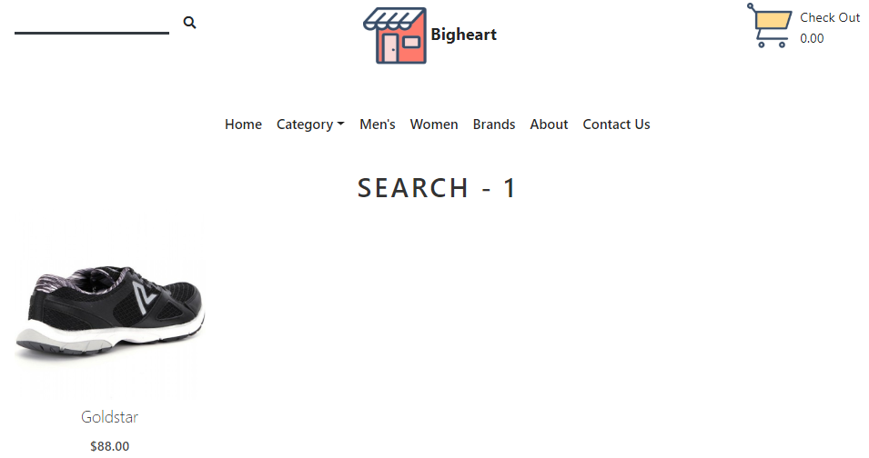

|  |  |
| --- | --- |
| **Test case no** | 4 |
| **Purpose of test** | To check store user can login |
| **Test data** | Email: [gold@gmail.com](mailto:gold@gmail.com)  Password: [gold@gmail.com](mailto:gold@gmail.com) |
| **Expected result** | Login in to dashboard |
| **Actual Result** | Logged into user dashboard |
| **Class** | testLogin, UserFactory |

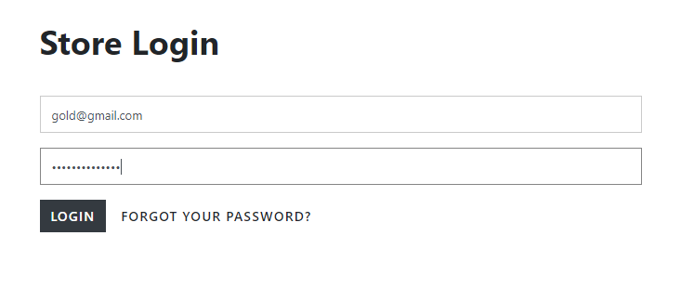

|  |  |
| --- | --- |
| **Test case no** | 5 |
| **Purpose of test** | To check whether product can be added or not |
| **Test data** | Cathleen Durham, Nobis placeat volup,892, 853 |
| **Expected result** | Product added |
| **Actual Result** | Product added successfully |
| **Test log (status)** | Passed |

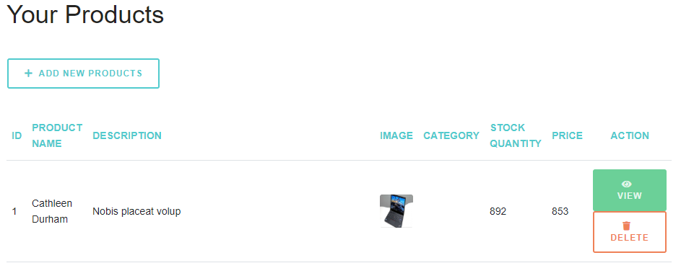

Figure 15: product added successfully

|  |  |
| --- | --- |
| **Test case no** | 6 |
| **Purpose of test** | To check customer can login |
| **Test data** | Email: [kiran@gmail.com](mailto:kiran@gmail.com)  Password: [kiran@gmail.com](mailto:kiran@gmail.com) |
| **Expected result** | Login in to home with authentication |
| **Actual Result** | Logged into home |
| **Test log (status)** | Passed |

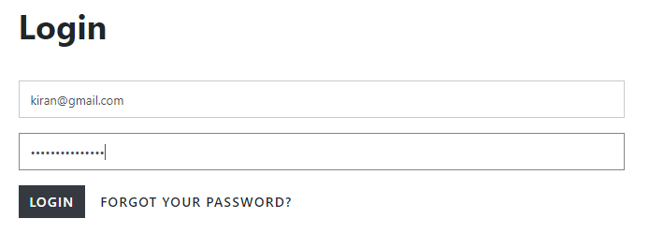

|  |  |
| --- | --- |
| **Test case no** | 7 |
| **Purpose of test** | To check whether user can add product to cart |
| **Test data** |  |
| **Expected result** | User should be able add product to cart |
| **Actual Result** | User can add product to cart |
| **Test log (status)** | passed |

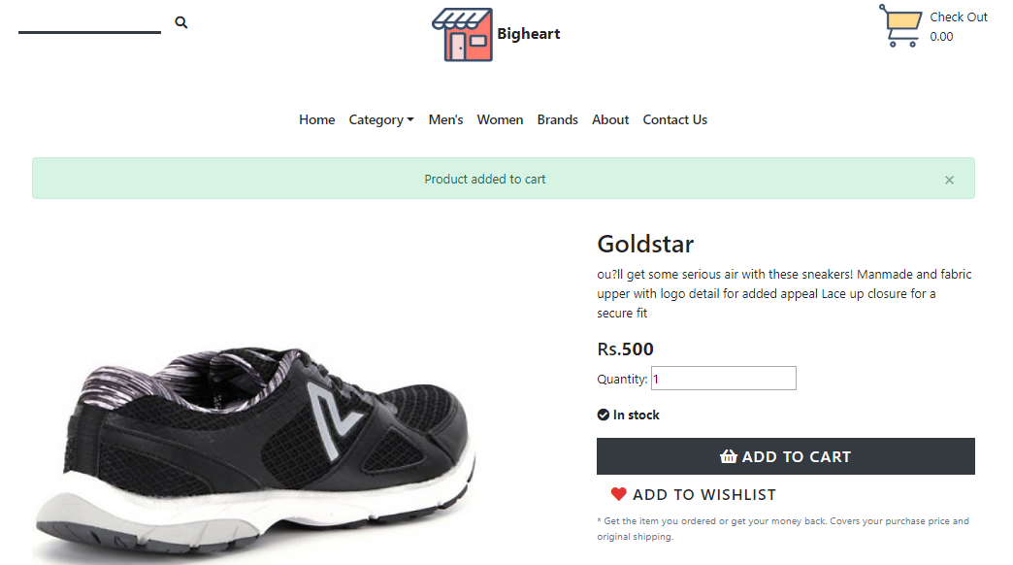

|  |  |
| --- | --- |
| **Test case no** | 8 |
| **Purpose of test** | To check whether user can input negative value in product quantity |
| **Test data** | -1 |
| **Expected result** | User should not be able to add negative value |
| **Actual Result** | User cannot add negative value. |
| **Class** | Product |

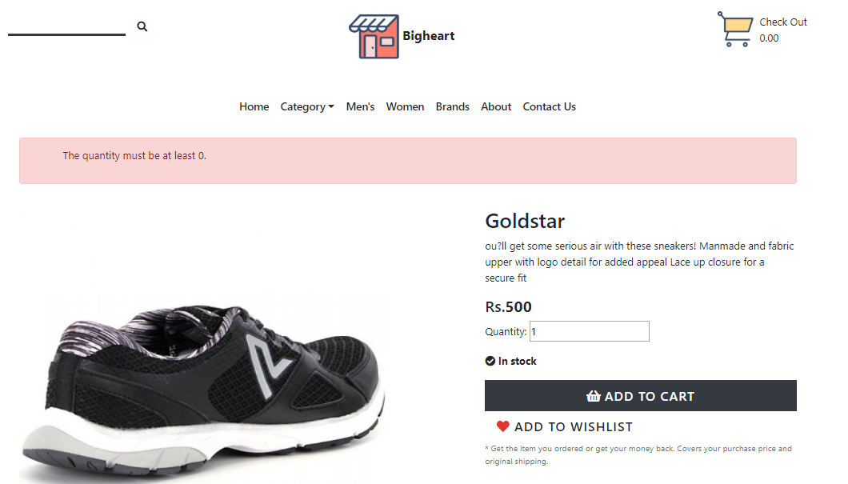

|  |  |
| --- | --- |
| **Test case no** | 9 |
| **Purpose of test** | To check whether user can add shipping address or not |
| **Test data** |  |
| **Expected result** | User should be able add shipping data |
| **Actual Result** | User can add shipping data |
| **Test log (status)** | passed |

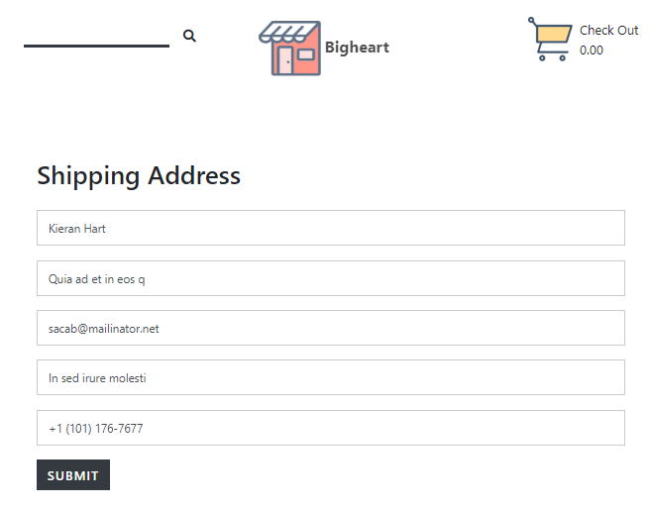

|  |  |
| --- | --- |
| **Test case no** | 10 |
| **Purpose of test** | To check whether user can order product |
| **Test data** |  |
| **Expected result** | User should be able add order product |
| **Actual Result** | User can add order product |
| **Test log (status)** | pass |



### Unit Testing.

It is level of testing where individual unit are tested to determine whether they are working or not. The testing is done by developer to make sure individual components are working as expected. The components like functions, procedures, classes, etc. are tested. The white box testing is used to test the unit testing.

**Test Case 1**

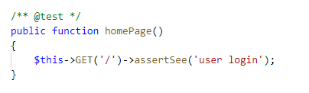

|  |  |
| --- | --- |
| **Test case no** | 1 |
| **Purpose of test** | To check route is working |
| **Test data** |  |
| **Expected result** | Visit home page |
| **Actual Result** | Successfully visited |
| **Class** | testLogin |

**Test case 2**

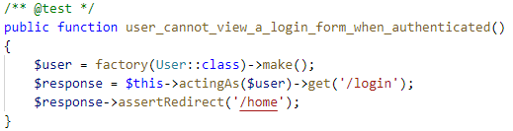

|  |  |
| --- | --- |
| **Test case no** | 2 |
| **Purpose of test** | To check user can login without authentication |
| **Test data** |  |
| **Expected result** | Redirect to login |
| **Actual Result** | Redirected to login |
| **Class** | testLogin, UserFactory |

**Test case 3**

|  |  |
| --- | --- |
| **Test case no** | 3 |
| **Purpose of test** | To check whether product can be added or not |
| **Test data** |  |
| **Expected result** | Product added |
| **Actual Result** | Product added successfully |
| **Class** | Product, Store |

**Test case 4**

|  |  |
| --- | --- |
| **Test case no** | 4 |
| **Purpose of test** | To check whether user can register themselves or not |
| **Test data** |  |
| **Expected result** | User should registered. |
| **Actual Result** | User is registered |
| **Class** | User, UserFactory |

**Test case 5**

|  |  |
| --- | --- |
| **Test case no** | 5 |
| **Purpose of test** | To check whether user can update their profile |
| **Test data** |  |
| **Expected result** | User should be able to update their profile |
| **Actual Result** | User can change profile |
| **Class** | User, UserFactory |

**Test case 6**

|  |  |
| --- | --- |
| **Test case no** | 6 |
| **Purpose of test** | To check whether user can add shipping address or not |
| **Test data** |  |
| **Expected result** | User should be able add shipping data |
| **Actual Result** | User can add shipping data |
| **Class** | Shipping |

**Test case 7**

|  |  |
| --- | --- |
| **Test case no** | 7 |
| **Purpose of test** | To check whether user can order product |
| **Test data** |  |
| **Expected result** | User should be able add order product |
| **Actual Result** | User can add order product |
| **Class** | Product |

**Test case 8**

|  |  |
| --- | --- |
| **Test case no** | 8 |
| **Purpose of test** | To check whether user can add product to cart |
| **Test data** |  |
| **Expected result** | User should be able add product to cart |
| **Actual Result** | User can add product to cart |
| **Class** | Product, Cart |

**Test case 9**

|  |  |
| --- | --- |
| **Test case no** | 9 |
| **Purpose of test** | To check whether user can search products or not |
| **Test data** | addidas |
| **Expected result** | User should be able to search products |
| **Actual Result** | User can search products |
| **Class** | Product |

**Test case 10**

|  |  |
| --- | --- |
| **Test case no** | 10 |
| **Purpose of test** | To check whether user can input negative value in product quantity |
| **Test data** | -1 |
| **Expected result** | User should not be able to add negative value |
| **Actual Result** | User cannot add negative value. |
| **Class** | Product |

# Other project issues

## Work Breakdown Structure

All the things a project needs to accomplish in the project is displays graphically which helps to understand the projects activities clearly. The purpose of WBS is to break down complex activities into simple form.

Figure 16: Work break down structure

## **Milestones**

|  |  |
| --- | --- |
| **Milestones** | **Date** |
| **Project Management**  Risk Management  Work Breakdown Structure  Configuration Management  Proposal Submission | **12/21/2018 -1/3/2019**  12/21/2018 - 12/24/2018  12/25/2018 - 12/27/2018  12/28/2018 - 12/30/2018  12/31/2018 - 1/1/2019 |
| **Analysis**  Requirement Analysis  Use Case  Architecture (Initial Class Diagram)  Analysis Specification | **1/2/2019 - 1/25/2019**  1/2/2019 - 1/7/2019  1/8/2019 - 1/11/2019  1/12/2019 - 1/17/2019  1/18/2019 - 1/25/2019 |
| **Design**  Structural Diagram  Behavioral Diagram  UI Design  Database Design | **1/26/2019 - 2/24/2019**  1/26/2019 - 2/3/2019  2/4/2019 - 2/13/2019  2/14/2019 - 2/20/2019  2/21/2019 - 2/24/2019 |
| **Implementation**  Building Database  Coding | **2/25/2019 - 3/28/2019**  2/25/2019 - 3/1/2019  3/2/2019 - 3/28/2019 |
| **Testing**  Unit Testing  Integration Testing  Blackbox Testing  Whitebox Testing | **3/29/2019 - 4/8/2019**  3/29/2019 - 3/31/2019  4/1/2019 - 4/3/2019  4/4/2019 - 4/6/2019  4/7/2019 - 4/8/2019 |
| **Deployment**  User Training  Final Report | **4/9/2019 - 4/18/2019**  4/9/2019 - 4/13/2019  4/14/2019 - 4/18/2019 |

**Description of Milestones:**

* **Project Management (12 days)**
* **Analysis (24 days)**
* **Design (30 days)**
* **Implementation (32 days)**
* **Testing (11 days)**
* **Deployment (10 days)**

## **Scheduling / Gantt Chart**

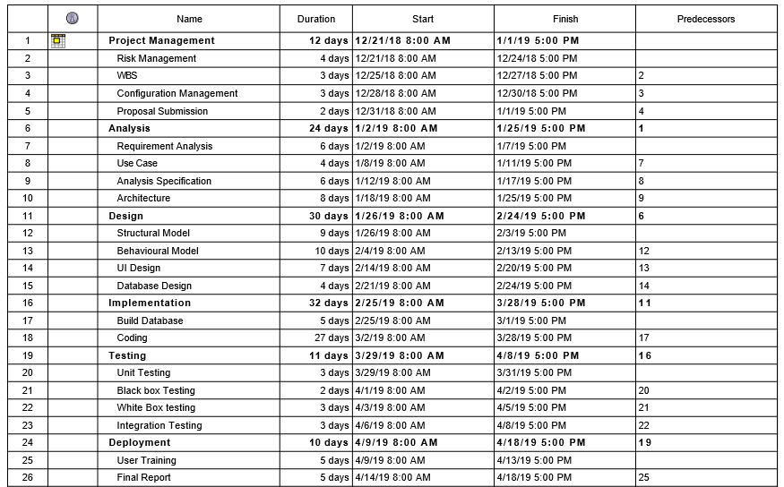

Figure 17: Scheduling time for tasks

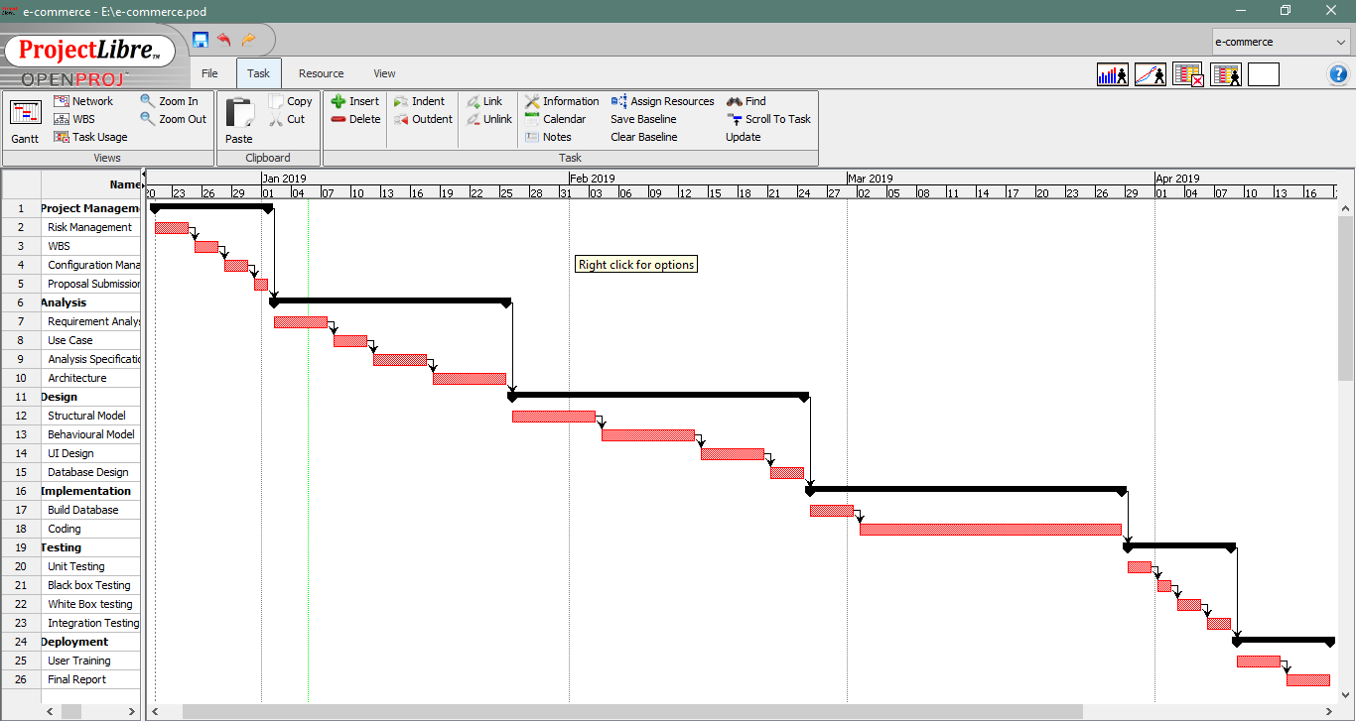

Figure 18: Gantt chart

# **Risk Management**

It is the process of identifying and prioritizing possible threats to an organization or system. Harmful risk is analyzed and solution to the threats are prepared.

**Impact = Likelihood * Consequences**

Risk Likelihood values are shown as follows

|  |  |
| --- | --- |
| **Likelihood** | **Value** |
| Low | 1 |
| Medium | 2 |
| High | 3 |

Risk Consequence values are shown below

|  |  |
| --- | --- |
| **Consequence** | **Value** |
| Very low | 1 |
| Low | 2 |
| Medium | 3 |
| High | 4 |
| Very High | 5 |

|  |  |  |  |  |  |
| --- | --- | --- | --- | --- | --- |
| **S. No** | **Risks** | **Likelihood** | **Consequences** | **Impact** | **Solution** |
|  | Lack of staff training | 2 | 3 | 6 | At the stage of deployment, staff should be trained properly to use the system. |
|  | Data theft | 3 | 4 | 12 | Strong company policy should be established. |
|  | Failure to meet requirement | 2 | 4 | 12 | Proper planning is to be done in every phase. |
|  | DDOS attack | 1 | 4 | 4 | Placing the publicly exposed server in DMZ. |
|  | Database error | 1 | 5 | 5 | Analyze the data traffic and upgrade the hardware if necessary. |
|  | Server failure | 1 | 5 | 5 | IT security should be hired to look after the server. |
|  | Change in government policy | 1 | 5 | 5 | Should be aware about the situation of the country and make changes accordingly. |

# 

# **Configuration Management**

Configuration management is used in this project to keep track of application and related information which includes software version and updates. It keeps track of modification, changes and update of my projects. I have used GitHub for configuration management because it is free and easy to use.

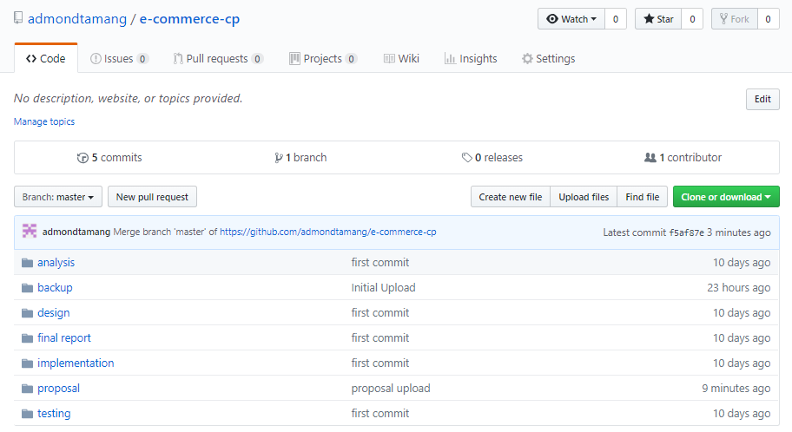

Figure 19: Github root directory

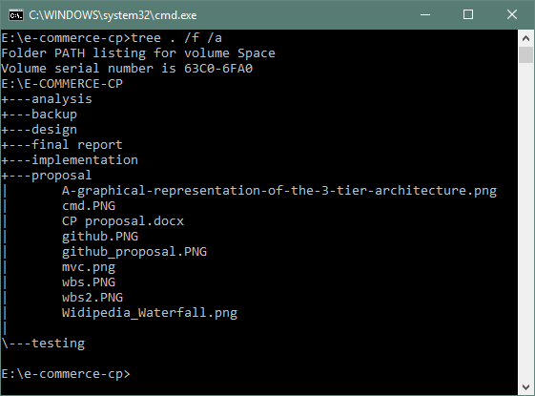

Figure 20: Local directory of project

# Conclusion

The Internet has become a major resource in modern business, thus electronic shopping has gained significance not only from the entrepreneur’s but also from the customer’s point of view. For the entrepreneur, electronic shopping generates new business opportunities and for the customer, it makes comparative shopping possible. As per a survey, most consumers of online stores are impulsive and usually decide to stay on a site within the first few seconds. “Website design is like a shop interior. If the shop looks poor or like hundreds of other shops the customer is most likely to skip to the other site. Hence, we have designed the project to provide the user with easy navigation, retrieval of data and necessary feedback as much as possible. In this project, the user is provided with an e-commerce web site that can be used to buy all types baby products online.

# References

Anon., n.d. [Online]   
Available at: https://www.visual-paradigm.com/guide/uml-unified-modeling-language/what-is-class-diagram/

# Appendix